Workshop 6
Java Collections and OOP Concepts
Melbourne Polytechnic
Student: 王一诺 Student ID: 4240102053
GitHub Link: (paste your repository link here before submitting)

How this workshop was completed
All seven exercises were written and run on a Windows machine with the JDK 21 toolchain. The source code of every program is included in this document and in the submitted GitHub repository; the console screenshots that follow each program were captured from the actual run, not typed by hand.
Item | Location in the submitted folder
Java source files | src/Exercise1.java ... Exercise7.java, src/Boxes.java
Compiled classes | bin/
Console output (plain text) | outputs/Exercise1.txt ... Exercise7.txt
Console screenshots | screenshots/Exercise1.png ... Exercise7.png
Every program is compiled and run from the project folder with the two commands below, so any exercise can be re-checked quickly:
javac -encoding UTF-8 -d bin src\*.java
java -cp bin Exercise1 (replace the class name for the other exercises)

Exercise 1 — Favourite songs and artists (Easy)
Task. Store ten favourite songs in one array of strings and the artists in a second array of strings, then print the list.
Approach. Two parallel arrays are filled in the same order, so index i always holds one song and its artist. A single for loop walks both arrays with the same index and prints the song number, the song and the artist. Using a loop instead of ten print statements means a song can be added or replaced in one place only.
Code — src/Exercise1.java
/*
* Workshop 6 - Exercise 1 (Easy)
* Store the names of 10 favorite songs and their artists in two arrays of strings,
* then output a list of the songs and artists.
*/
public class Exercise1 {
public static void main(String[] args) {
// 10 favourite songs
String[] songs = {
"Bohemian Rhapsody",
"Hotel California",
"Imagine",
"Shape of You",
"Rolling in the Deep",
"Take Me Home, Country Roads",
"Blinding Lights",
"Someone Like You",
"Counting Stars",
"See You Again"
};
// the artist of each song (same index as the song array)
String[] artists = {
"Queen",
"Eagles",
"John Lennon",
"Ed Sheeran",
"Adele",
"John Denver",
"The Weeknd",
"Adele",
"OneRepublic",
"Wiz Khalifa ft. Charlie Puth"
};
System.out.println("My 10 Favourite Songs");
System.out.println("=====================");
for (int i = 0; i < songs.length; i++) {
System.out.println((i + 1) + ". " + songs[i] + " - " + artists[i]);
}
}
}
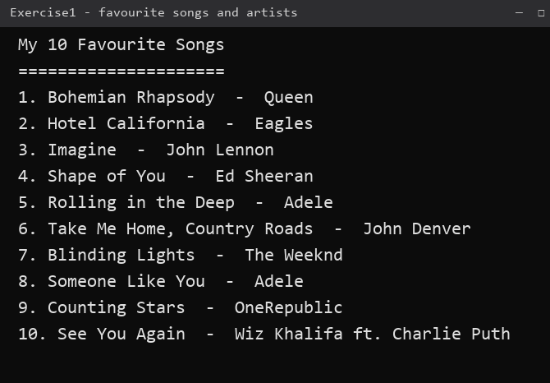
Figure 1 Console output of Exercise1.java

Exercise 2 — Alphabetical order with bubble sort (Hard)
Task. Modify Exercise 1 so that the songs are printed in alphabetical order; the hint is to use bubble sort.
Approach. Bubble sort compares two neighbouring songs with compareToIgnoreCase and swaps them when the left one should come later in the dictionary. Each pass pushes the largest remaining song to the end, so the inner loop can stop one element earlier every time. When a swap happens, the artist in the second array is swapped at the same index, which is what keeps song and artist paired. Ten items are sorted after at most nine passes; on this data the array is already ordered after the output shown below.
Code — src/Exercise2.java
/*
* Workshop 6 - Exercise 2 (Hard)
* Exercise 1 modified so the songs are output in alphabetical order.
* Hint: bubble sort. The artist array is sorted together with the song array
* so that each song keeps its own artist.
*/
public class Exercise2 {
public static void main(String[] args) {
String[] songs = {
"Bohemian Rhapsody",
"Hotel California",
"Imagine",
"Shape of You",
"Rolling in the Deep",
"Take Me Home, Country Roads",
"Blinding Lights",
"Someone Like You",
"Counting Stars",
"See You Again"
};
String[] artists = {
"Queen",
"Eagles",
"John Lennon",
"Ed Sheeran",
"Adele",
"John Denver",
"The Weeknd",
"Adele",
"OneRepublic",
"Wiz Khalifa ft. Charlie Puth"
};
// ---------- bubble sort ----------
for (int pass = 0; pass < songs.length - 1; pass++) {
for (int i = 0; i < songs.length - 1 - pass; i++) {
// compareToIgnoreCase puts the song that comes first in the
// dictionary in front (so upper/lower case does not matter)
if (songs[i].compareToIgnoreCase(songs[i + 1]) > 0) {
String tempSong = songs[i];
songs[i] = songs[i + 1];
songs[i + 1] = tempSong;
String tempArtist = artists[i];
artists[i] = artists[i + 1];
artists[i + 1] = tempArtist;
}
}
}
System.out.println("Songs in Alphabetical Order");
System.out.println("============================");
for (int i = 0; i < songs.length; i++) {
System.out.println((i + 1) + ". " + songs[i] + " - " + artists[i]);
}
}
}
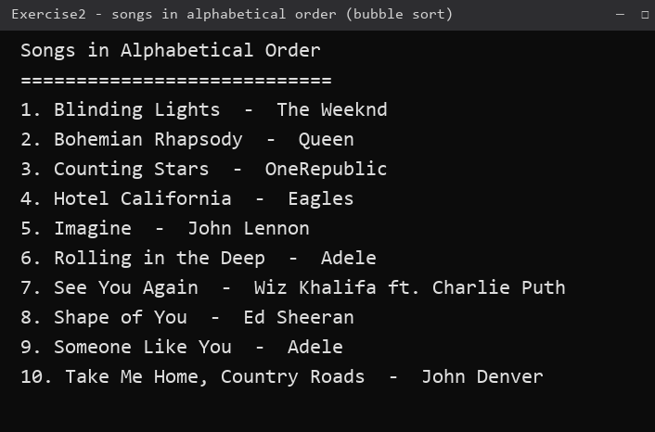
Figure 2 Console output of Exercise2.java — the same ten songs, now in alphabetical order

Exercise 3 — Reversing the letters of each word (Medium)
Task. Reverse the letters of every word in a sentence with loops and arrays, so that "To be or not to be." becomes "oT eb ro ton ot eb.".
Approach. The sentence is split into a String array. For each word the program first finds where the letters end, so that the full stop in "be." is not reversed. The letters are copied into a char array from the last letter to the first, rebuilt into a String with a loop, and the punctuation is appended again. Splitting on the space and re-joining with one space also normalises any double spaces.
Code — src/Exercise3.java
/*
* Workshop 6 - Exercise 3 (Medium)
* Reverse the sequence of letters in each word of a sentence using loops and arrays.
* "To be or not to be." -> "oT eb ro ton ot eb."
* Punctuation stays where it is, only the letters of each word are reversed.
*/
public class Exercise3 {
public static void main(String[] args) {
String sentence = "To be or not to be.";
System.out.println("Original : " + sentence);
System.out.println("Reversed : " + reverseWords(sentence));
}
// Split the sentence into words (array), then reverse the letters of
// every word character by character with loops.
public static String reverseWords(String sentence) {
String[] words = sentence.split(" ");
String result = "";
for (int w = 0; w < words.length; w++) {
String word = words[w];
// find where the letters end, e.g. "be." -> letters = "be"
int letterEnd = word.length();
while (letterEnd > 0 && !Character.isLetter(word.charAt(letterEnd - 1))) {
letterEnd--;
}
char[] letters = new char[letterEnd];
for (int i = 0; i < letterEnd; i++) {
letters[i] = word.charAt(letterEnd - 1 - i); // reverse order
}
String reversedWord = "";
for (int i = 0; i < letters.length; i++) {
reversedWord = reversedWord + letters[i];
}
// put the punctuation back on the end
for (int i = letterEnd; i < word.length(); i++) {
reversedWord = reversedWord + word.charAt(i);
}
if (w > 0) {
result = result + " ";
}
result = result + reversedWord;
}
return result;
}
}
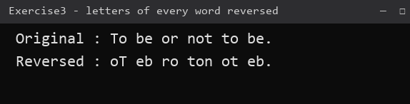
Figure 3 Console output of Exercise3.java — matches the example in the question

Exercise 4 — Decoding the coded message (Easy)
Task. Decode "G tgsl Qefe." with the substitution table given in the question, and keep the program easy to change for a different message.
Approach. The table is stored as two character arrays: CODE holds the coded letters in alphabet order and PLAIN holds the letters they decode to, so the pair at the same index is one substitution (a→c, b→r, …). For each character the program looks up its position in CODE and copies the letter at the same position of PLAIN. Characters that are not in the table, such as the space and the full stop, are copied unchanged, and the case of the original letter is preserved, which is why the capital G becomes I and the capital Q becomes J. The message is a single constant, so decoding a new message only means replacing that string or passing it as a command line argument.
Code — src/Exercise4.java
/*
* Workshop 6 - Exercise 4 (Easy)
* Decode the coded message "G tgsl Qefe." using the given substitution table.
*
* a->c b->r c->g d->z e->a f->v g->i h->b i->s j->d k->o l->e m->q
* n->f o->h p->u q->j r->x s->k t->l u->w v->m w->y x->n y->p z->t
*
* To decode a different message just change the CODED_MESSAGE constant
* (or pass the message as a command line argument).
*/
public class Exercise4 {
// the coded letters, in alphabet order (a b c ... z)
private static final char[] CODE = "abcdefghijklmnopqrstuvwxyz".toCharArray();
// the letters they decode to (c r g z a v i b s d o e q f h u j x l w m y n p t)
private static final char[] PLAIN = "crgzavibsdoeqfhujxklwmynpt".toCharArray();
private static final String CODED_MESSAGE = "G tgsl Qefe.";
public static void main(String[] args) {
String coded = (args.length > 0) ? args[0] : CODED_MESSAGE;
System.out.println("Coded message : " + coded);
System.out.println("Decoded message : " + decode(coded));
}
public static String decode(String message) {
char[] input = message.toCharArray();
char[] output = new char[input.length];
for (int i = 0; i < input.length; i++) {
char c = input[i];
char lower = Character.toLowerCase(c);
int position = -1;
for (int k = 0; k < CODE.length; k++) {
if (CODE[k] == lower) {
position = k;
break;
}
}
if (position == -1) {
// space, full stop or any other character: copy it unchanged
output[i] = c;
} else {
char decoded = PLAIN[position];
// keep the original case: 'G' -> 'I', 'g' -> 'i'
output[i] = Character.isUpperCase(c) ? Character.toUpperCase(decoded) : decoded;
}
}
return new String(output);
}
}
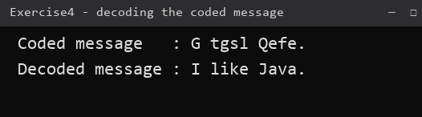
Figure 4 Console output of Exercise4.java — "G tgsl Qefe." decodes to "I like Java."

Exercise 5 — Search engine over ten paragraphs (Medium)
Task. Store ten paragraphs in a String array and search them for a phrase: print the index and the paragraph of every match, or state that the phrase was not found.
Approach. A for loop passes over all ten paragraphs, so every match is reported rather than only the first one. The test uses String.contains() on the paragraph and on the phrase after both have been converted to lower case, which makes the search case insensitive without changing the stored text. A counter decides which of the two closing messages is printed. The phrase is taken from the command line when one is given, otherwise the default "keyword search" is used, so the program can be tried with phrases that do not occur at all.
Code — src/Exercise5.java
/*
* Workshop 6 - Exercise 5 (Medium)
* Search Engine: search through an array of 10 paragraphs.
* Output the index and the paragraph of every match, or a message saying
* the phrase was not found.
*/
public class Exercise5 {
public static void main(String[] args) {
String[] paragraphs = {
"Lose all the weight you want.",
"I can't I must work",
"That would be like a keyword search.",
"This would be Victoria.",
"Join the party.",
"To be or not to be.",
"That is a question to test keyword search.",
"Can you find a needle in a hay stack?",
"This could be the last paragraph, but its not.",
"Ada Lovelace is the worlds first programmer as of 1860."
};
String phrase = (args.length > 0) ? args[0] : "keyword search";
System.out.println("Search phrase: \"" + phrase + "\"");
System.out.println("---------------------------------------------");
int found = 0;
for (int i = 0; i < paragraphs.length; i++) {
// ignore upper/lower case so the search is not case sensitive
if (paragraphs[i].toLowerCase().contains(phrase.toLowerCase())) {
System.out.println("Found at index " + i + ": " + paragraphs[i]);
found++;
}
}
System.out.println("---------------------------------------------");
if (found == 0) {
System.out.println("The phrase \"" + phrase + "\" was NOT found in any paragraph.");
} else {
System.out.println(found + " paragraph(s) contained the phrase.");
}
}
}
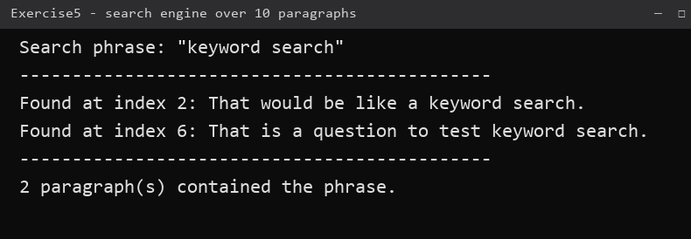
Figure 5 Console output of Exercise5.java for the phrase "keyword search"

Exercise 6 — Class variables and instance variables (Easy)
Task. The class below is given in the question and has to be analysed.
public class IdentifyMyParts {
public static int x = 7;
public int y = 3;
}
(a) Class variable: x, because it is declared static — one copy belongs to the class itself and is shared by every object. It is written IdentifyMyParts.x in code.
(b) Instance variable: y, because it is declared without static — every object created with new gets its own copy. In the printed output a.y and b.y are therefore different.
(c) Output. The static variable is assigned twice (a.x = 1, then b.x = 2) and both assignments write the same single variable, so the last value, 2, is what every reader of x sees. The two instance variables are independent, so a.y keeps 5 and b.y keeps 6. Java allows a static variable to be reached through an object reference such as a.x, but it gives a warning because it looks like an instance variable and hides the fact that the value is shared.
Printed line | Output | Reason
a.y = 5 | 5 | a has its own y, set to 5
b.y = 6 | 6 | b has its own y, set to 6
a.x = 2 | 2 | x is shared; a.x = 1 was overwritten by b.x = 2
b.x = 2 | 2 | the same static variable again
IdentifyMyParts.x = 2 | 2 | the single copy of x that belongs to the class
Code — the program that prints the output above: src/Exercise6.java
/*
* Workshop 6 - Exercise 6 (Easy)
* Demonstration program for the class IdentifyMyParts.
* It runs exactly the code given in the question so the output can be checked.
*/
public class Exercise6 {
static class IdentifyMyParts {
public static int x = 7; // class (static) variable
public int y = 3; // instance variable
}
public static void main(String[] args) {
IdentifyMyParts a = new IdentifyMyParts();
IdentifyMyParts b = new IdentifyMyParts();
a.y = 5;
b.y = 6;
a.x = 1;
b.x = 2;
System.out.println("a.y = " + a.y);
System.out.println("b.y = " + b.y);
System.out.println("a.x = " + a.x);
System.out.println("b.x = " + b.x);
System.out.println("IdentifyMyParts.x = " + IdentifyMyParts.x);
}
}
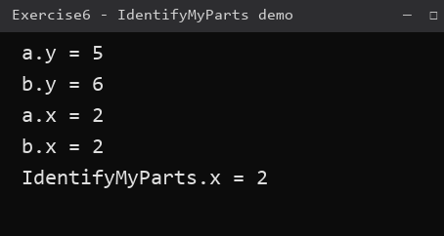
Figure 6 Console output of Exercise6.java

Exercise 7 — The Boxes class (Medium)
Task. Write a Boxes class that draws a square box of any size up to 10 with '-' for the top and bottom and '|' for the sides, plus a driver class that tests it. The Boxes class needs a constructor that accepts the size, a method that sets the size, a toString() that returns the size as a String such as "10 x 10", and a method that draws the box.
Approach. The size is kept in a private field that can only be changed through setSize(), and setSize() throws IllegalArgumentException for anything outside 1 to 10, so an illegal box can never be drawn. draw() goes through the rows: the first and last row are size dashes, every other row is a '|', size-2 spaces and a closing '|'. Because the width of a console character is taller than it is wide, a 10 x 10 box looks taller on screen than it is wide, which is expected in a character-based drawing. drawUnicode() is the extension from the question and uses the line character \u2500 for the top and bottom. The driver prints toString() before each drawing, changes the size of an existing object with setSize(8), draws the maximum box of 10, and shows that 12 is rejected.
Code — Boxes.java: src/Boxes.java
/*
* Workshop 6 - Exercise 7 (Medium)
* The Boxes class: draws a square box on the console.
* The maximum size is 10.
*/
public class Boxes {
public static final int MAX_SIZE = 10;
public static final int MIN_SIZE = 1;
private int size;
// constructor that accepts the size of the box
public Boxes(int size) {
setSize(size);
}
// method that sets the size of the box
public void setSize(int size) {
if (size < MIN_SIZE || size > MAX_SIZE) {
throw new IllegalArgumentException(
"Box size must be between " + MIN_SIZE + " and " + MAX_SIZE + ", but was " + size);
}
this.size = size;
}
public int getSize() {
return size;
}
// returns the size of the box as a String, e.g. "10 x 10"
@Override
public String toString() {
return size + " x " + size;
}
// draws the box with '-' for the top/bottom and '|' for the sides
public void draw() {
for (int row = 0; row < size; row++) {
if (row == 0 || row == size - 1) {
System.out.println(repeat('-', size)); // top and bottom
} else {
System.out.println("|" + repeat(' ', size - 2) + "|"); // sides
}
}
}
// extension: the same box drawn with the Unicode line character \u2500
public void drawUnicode() {
char top = '\u2500';
char side = '\u2502';
for (int row = 0; row < size; row++) {
if (row == 0 || row == size - 1) {
System.out.println(repeat(top, size));
} else {
System.out.println(side + repeat(' ', size - 2) + side);
}
}
}
// small helper: a String made of the same character repeated n times
private static String repeat(char c, int n) {
String s = "";
for (int i = 0; i < n; i++) {
s = s + c;
}
return s;
}
}
Code — Exercise7.java (driver class): src/Exercise7.java
/*
* Workshop 6 - Exercise 7 (Medium)
* Driver class: contains main() and makes calls to the Boxes class.
*/
public class Exercise7 {
public static void main(String[] args) {
// test 1: a 5 x 5 box created by the constructor
Boxes box = new Boxes(5);
System.out.println("Box size: " + box);
box.draw();
System.out.println();
// test 2: the same object, size changed to 8 x 8
box.setSize(8);
System.out.println("Box size: " + box);
box.draw();
System.out.println();
// test 3: the biggest allowed box (10 x 10)
Boxes big = new Boxes(Boxes.MAX_SIZE);
System.out.println("Box size: " + big);
big.draw();
System.out.println();
// test 4: a size above the maximum is rejected
try {
Boxes invalid = new Boxes(12);
invalid.draw();
} catch (IllegalArgumentException e) {
System.out.println("Invalid box: " + e.getMessage());
}
// extension: the Unicode line character \u2500 version
System.out.println();
Boxes unicodeBox = new Boxes(6);
System.out.println("Box size (Unicode line): " + unicodeBox);
unicodeBox.drawUnicode();
}
}
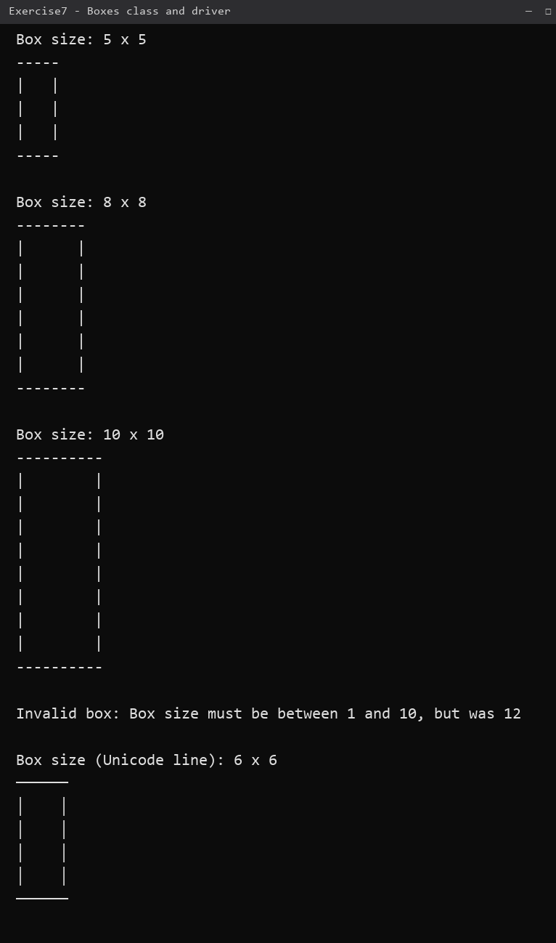
Figure 7 Console output of Exercise7.java — 5 x 5, 8 x 8, 10 x 10, the rejected size and the Unicode box

